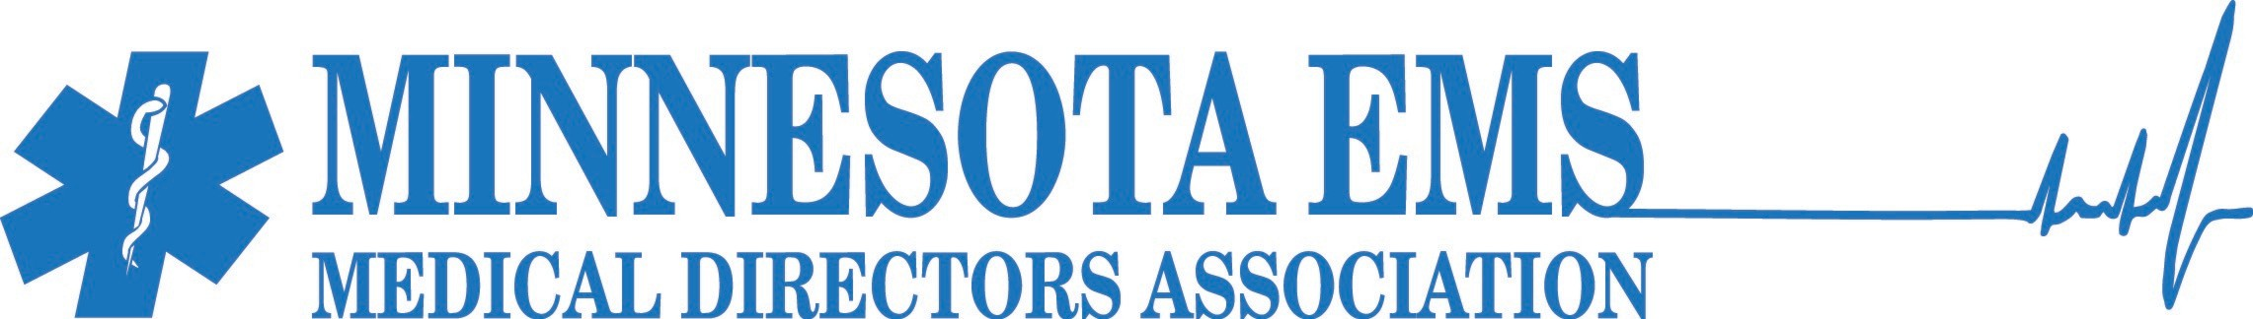

June 2026

PLEASE PLAN TO PARTICIPATE!

2026 Minnesota EMS Medical Directors Conference
Theme: State of the Art of EMS
October 13–15, 2026 — Greysolon Plaza, Duluth, Minnesota

Dear Educational Partners:

The Minnesota EMS Medical Directors Association invites you to participate as a valued sponsor and exhibitor at our upcoming annual conference. Moving to the historic Greysolon Plaza in Duluth, this year’s event marks a high-energy reinvigoration of our gathering, bringing together physician EMS medical directors, ambulance service chiefs, and healthcare executives from across the state. We have several exciting, modernized opportunities for industry and educational partners to showcase their services and connect directly with key decision-makers. You may register online at www.mnemsmd.com.

This is a planned activity with continuing medical education (CME) credit offered for physicians as well as other healthcare professionals. Please watch our webpage for ongoing updates, including the complete schedule layout and finalized lodging block links at our adjacent partner hotel, the Sheraton Duluth.

Dr. Anuradha Luke is on the association board and serves as our liaison for industry support. You may connect with Dr. Luke at Luke.Anuradha@mayo.edu regarding specific questions about the clinical conference content. For administrative questions regarding exhibitor opportunities, scheduling, or venue setup logistics, please contact Conference Management via email at mnemsmd.office@gmail.com.

Your support and participation is absolutely vital. All sponsorship revenue directly offsets the immense expense of offering a high-quality educational and networking activity for our state's EMS leadership. All participating partners will be prominently acknowledged on our website and across official conference materials.

Sponsor registration and electronic credit card payments can be securely processed online. The Minnesota EMS Medical Director’s Education Association, Inc. EIN is 20-0658684.

We genuinely hope you will join us in the heart of the Zenith City this October to help shape the future of emergency medical services. Thank you for your continued partnership, consideration, and support of continuing medical education.

Warm regards,

Conference Management
Minnesota EMS Medical Directors Association
Email: mnemsmd.office@gmail.com
Website: www.mnemsmd.com

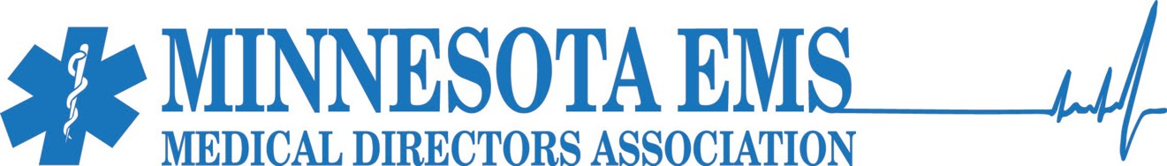

SUPPORT THE CONFERENCE
The Minnesota EMS Medical Directors Association invites our industry and educational partners to participate as sponsors and exhibitors for the 2026 State of the Art of EMS Conference. Moving to the historic Greysolon Plaza in Duluth, this year’s event marks a high-energy reinvigoration of our annual gathering, bringing together physician medical directors, ambulance service chiefs, and healthcare executives from across the state.

Your involvement is vital. All financial support directly offsets the expense of hosting a premier continuing medical education (CME) activity of this caliber. In return, our packages offer prominent visibility, dedicated networking blocks, and full access to the conference sessions.

REASONS TO PARTNER WITH US
- Targeted Executive Audience: Connect directly with 80 to 100 key decision-makers, including EMS medical directors and their dyad operations chief counterparts.
- High-Impact Engagement: The exhibitor spaces are seamlessly integrated into high-traffic blocks, including the Tuesday evening Welcome Reception, daily breakfasts, and dedicated refreshment breaks.
- Full Conference Access: Each registration includes two vendor badges, granting your representatives full access to attend all educational sessions and our new MN EMS Ignite blocks.
- Prominent Recognition: All corporate and educational partners will be recognized on the conference website and throughout the official event materials.

Exhibits will take place on Wednesday, October 14th and Thursday, October 15th.
- Set up: Tuesday, October 13th from 3:00 PM – 5:00 PM.
- Take down: Thursday, October 15th following the morning refreshment break.

Our sponsors and exhibitors are an important part of our conference, and we have heard your feedback and appreciate you sharing it with us. We are committed to making your experience both valuable and rewarding. We have built plenty of opportunities into the schedule for meaningful interaction with attendees, helping you maximize your visibility and connections throughout the event. We also hope you will join us for our Tuesday evening Welcome Reception and Networking Event, which is a great opportunity to meet attendees and start building relationships before the conference begins. The exhibitor hall is open during all meals, conference breaks, and the Welcome Reception on Tuesday evening.

Please watch our conference webpage for updates, including our online process to register as an exhibitor. Your support is truly needed and appreciated! We hope to see you there.

Conference webpage: www.mnemsmd.com
Contact: mnemsmd.office@gmail.com

MN EMS MEDICAL DIRECTORS ASSOCIATION BOARD
- Anuradha Luke, MD, Mayo Clinic
- Tim Kummer, MD, Hennepin Healthcare
- Alec Bunting, DO, Hennepin Healthcare
- Dave Collins, MD, Ortonville Area Health Service
- Kari Haley, MD, HealthPartners

Conference Advisory Group: Please see our webpage for a complete listing.

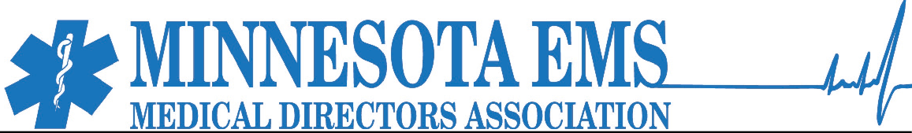

SUPPORT LEVELS & PACKAGES
Major Supporter | $3,000.00
- Deadline: July 15, 2026 (Limited availability, awarded on a first-come, first-served basis).
- Exhibitor Space: Prime placement with two exhibit tables.
- Premium Branding: Featured logo and direct website link placed on the official conference website.
- Exclusive Co-Hosting: Recognized as a primary co-host for one of our premier social highlights, with dedicated signage at the event.

Platinum Supporter | $2,500.00
- Deadline: September 15, 2026.
- Exhibitor Space: Premium placement with two exhibit tables.
- Digital Branding: Logo and website link featured on the conference website.
- Event Recognition: Dedicated acknowledgment as an evening event host.

Gold Supporter | $2,000.00
- Deadline: September 15, 2026.
- Exhibitor Space: Preferred placement with one exhibit table.
- Digital Branding: Logo and website link featured on the conference website.
- Event Recognition: Special recognition as a conference meal host.

Silver Supporter | $1,500.00
- Deadline: September 15, 2026.
- Exhibitor Space: General placement with one exhibit table.
- Digital Branding: Logo and website link featured on the conference website.
- Event Recognition: Named recognition as a refreshment break host.

Non-Profit Organizations: We offer special discounted rates for non-profit entities looking to exhibit. Please reach out to conference management for custom pricing details.

EXHIBITOR LOGISTICS & TIMELINE
Exhibits will take place at the Greysolon Plaza, offering excellent proximity to the main presentation tracks.
- Exhibitor Setup: Tuesday, October 13, 2026, from 3:00 PM to 5:00 PM.
- Exhibitor Hall Open: Kickoff begins Tuesday evening during the Welcome Reception (6:00 PM – 10:00 PM) and remains open through Wednesday's full schedule.
- Exhibitor Teardown: Thursday, October 15, 2026, following the morning refreshment break.

HOW TO REGISTER
An online portal is being finalized to handle all sponsor registrations and credit card payments electronically. A direct form link will be added to this page as soon as it goes live.

For specific questions regarding conference content, educational alignment, or unique support opportunities, please contact the Association Board. For questions regarding the schedule, space layouts, or setup details, please contact Conference Management at mnemsmd.office@gmail.com.

